FACULTY EVALUATION
Programme Name: Social Entrepreneurship Development Program (SEDP)- Start Tanzania Module 3 (2nd February - 6th February 2026)
Session: Funding sources
Faculty Name: Dr. Isaac Muiruri Gachanja
No. of Respondents: 16
No. of Participants: 16
Evaluation Parameter | (%) Individual Score | (%) Programme Average
Punctuality (Commencement and Completion of Sessions) | 94 | 95
How well do you understand the core concepts presented? | 88 | 87
Rate your confidence in applying the new skills learnt | 89 | 88
Degree of Faculty preparedness for the sessions | 91 | 91
Content and methodology of the program | 92 | 91
Quality of class and group discussions | 90 | 89
The information presented in the course is relevant to my work (ministry) | 92 | 91
Average scores | 91 | 90

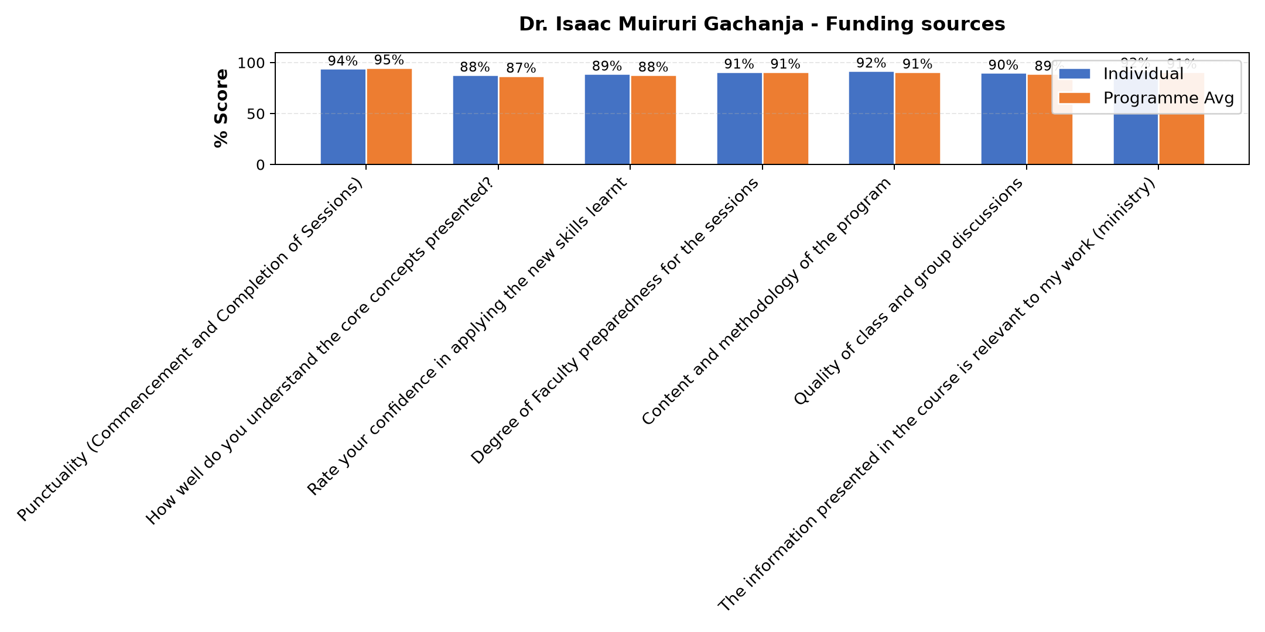

Comments & Feedback
- • Good
- • Nitajitahidi kutumia elimu niliyoipata kuinufaisha jamii pia
- • If I stay for a long time without implementing it, I will not achieve it.Goals
- • Asante kwa mafundisho mazuri nitajitahidi kuyafanyia kazi
- • Confidence
- • If I stay without implementing for a long time, I will fail to achieve my goals.
- • Smart
- • To find a capital in different areas
- • Nashukuru Mwalimu Isaac kwa kutufundisha vizuri
SUBMITTED THROUGH:
SBS Evaluation Automation System

